

LOVELY PROFESSIONAL UNIVERSITY

SCHOOL OF COMPUTER SCIENCE AND ENGINEERING

CA 3 PROJECT REPORT

INT-301

OPEN-SOURCE TECHNOLOGY

INT301: Open-Source Technologies

CA3

Submitted to Mr: Rajeshwar Sharma

Name: G Kartheshwar

Roll number:RKE002A34

Reg Number:12014169

QUESTON:

Use any open-source software to generate your entire system's log report of past 3 months

along with this find partial and full multimedia files (video files) in DataStream.

**OBJECTIVE:**

The system log is a direct access data set that stores the commands and notifications. Logging is a method of tracking and storing data to ensure application availability and to assess the impact of state transformations on performance. Monitoring is tool used for alerting Devops to System-related issues by analysing metrics. It helps in detecting and locate bugs easily when developing software or in the software which can be fixed easily and help the user to get good user experience

**DESCRPTION:**

Elastic is an open-source software which I have used for generating system log report. Log Monitoring Scalable, centralized log monitoring for hybrid cloud as the recognized leader in log monitoring, with the broadest and most comprehensive set of log data sources in the industry, the Elastic Stack (also known as the ELK Stack) is the most popular free and open logging platform.

USES OF ELASTIC:

* View your deployment’s health and performance in real time and analyse past cluster, index, and node metrics.
* View your deployment’s logs to debug issues, discover slow queries, surface deprecations, and analyse access to your deployment

In this I have also used Event viewer application software to generate the systems log report. Because elastic is available only for 15 days to use and after that it requires for an subscription. [Event Viewer is an application that shows a log detailing information about significant events on your computer such as automatically downloaded updates, errors, and warnings](https://www.freecodecamp.org/news/event-viewer-how-to-access-the-windows-10-activity-log/). It is a software which can be used by every windows operating system machine for free. Each program you open on your Windows 10 computer sends a notification to a particular activity log in the Event Viewer. All other activity such as OS changes, security updates, driver quirks, hardware failure, and so on are also posted to a particular log. So, you can think of the event viewer as a database that records every activity on your computer. With the event viewer, you can troubleshoot different Windows and application issues. If you explore the event viewer in-depth, you will see different information, warnings, and plenty of errors. Don’t freak out – this is normal. Even the best-maintained computers show plenty of errors and warnings.

**How to Access the Windows 10 Activity Log through the Start Menu**

**Step 1**: Click on Start or press the Windows key on your keyboard  
**Step 2**: Search for Event Viewer  
**Step 3**: Click on the first search result or press ENTER

When you open the event viewer to see your computer's activity logs, you are automatically shown the Event Viewer (Local) tab. But this might not contain the details you need, as it's just a page you are greeted with when you open the Event Viewer.

**SCOPE OF THE PROJECT:**

Log management system will be very handy when particular file or document missing, we can use log management tool in that case so that we can fetch the details of the file or document. but in this it will be very helpful to view the user’s login this will help in to find that at how productive the user has been while using the system this help to analyse and generate report on the particular user which can be used by many large MNC to monitor their workers without any external agent

**SYSTEM DESCREPTION:**

ELASTIC HAVE USED PREDEFINED SYSTEM REPORT AVILABLE IN THE SYSTEM.

EVENT VIEWR USED: MICROSOFT WINDOWS11 OS

**FUNCTIONAL DEPENDENCIES:**

IMPORT ELASTIC PUBLIC GPG KEY

sudo rpm --import <http://packages.elasticsearch.org/GPG-KEY-elasticsearch>

**ANALYSIS REPORT:**

ELASTIC OPEN-SOURCE SOSTWARE SYSTEM LOG SCREENSHOT:

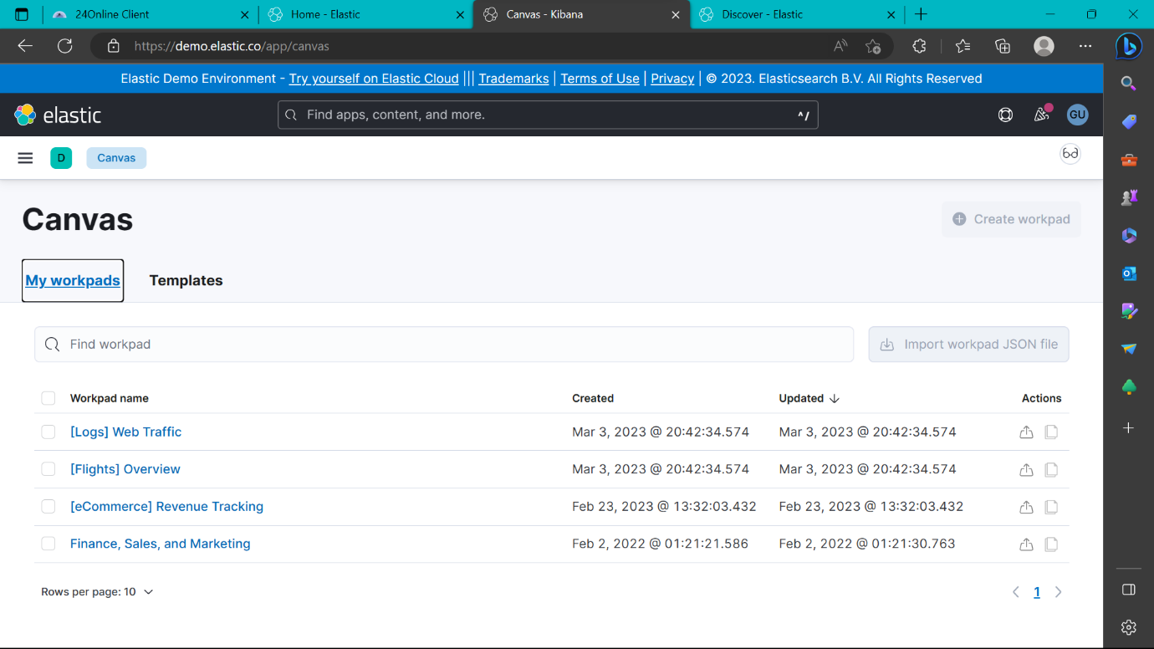

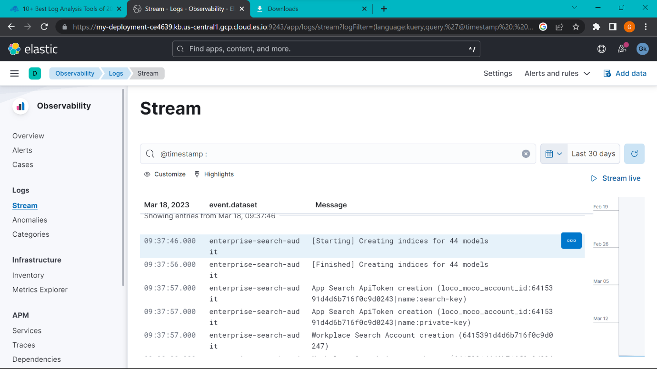

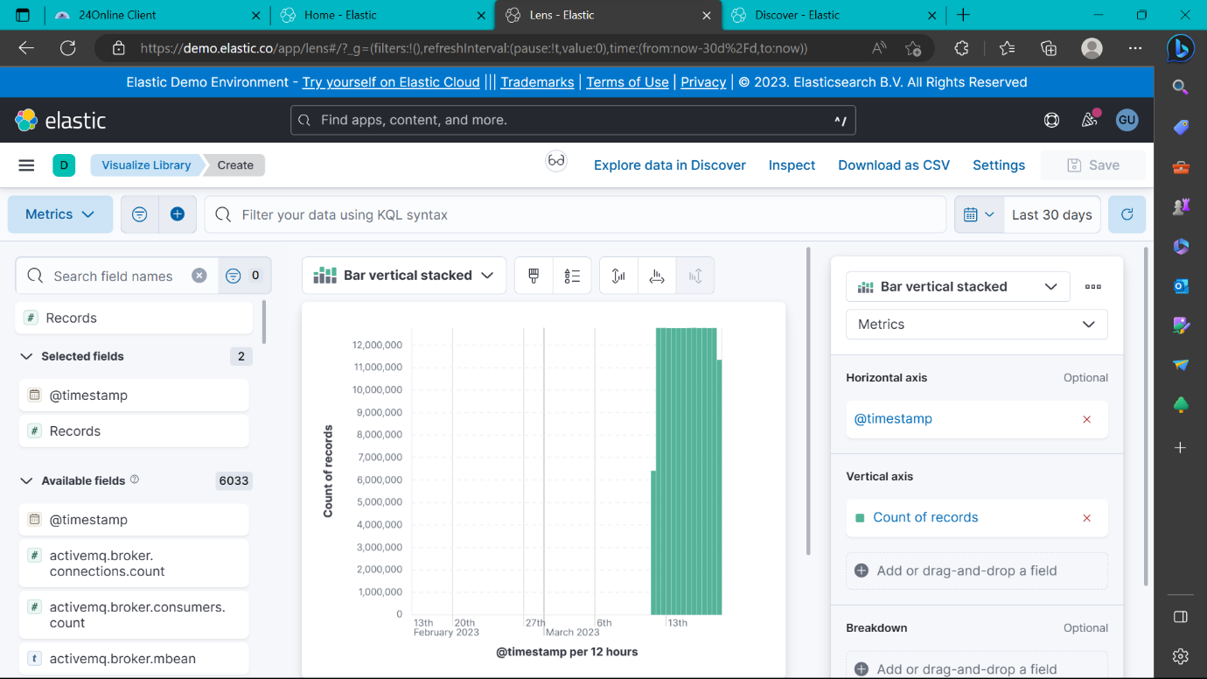

EVENT VIEWER SCREEN SHOT:

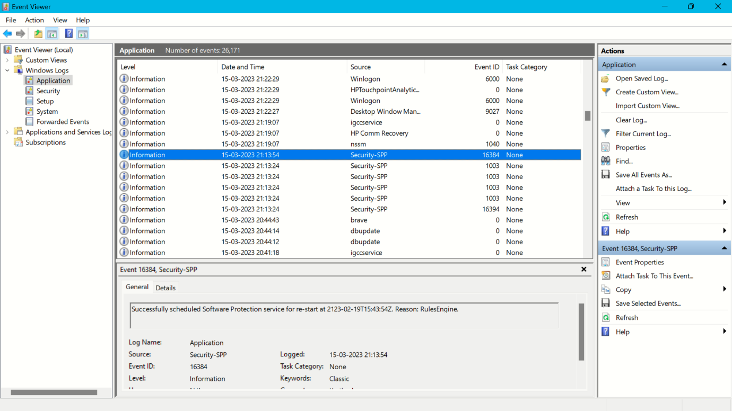

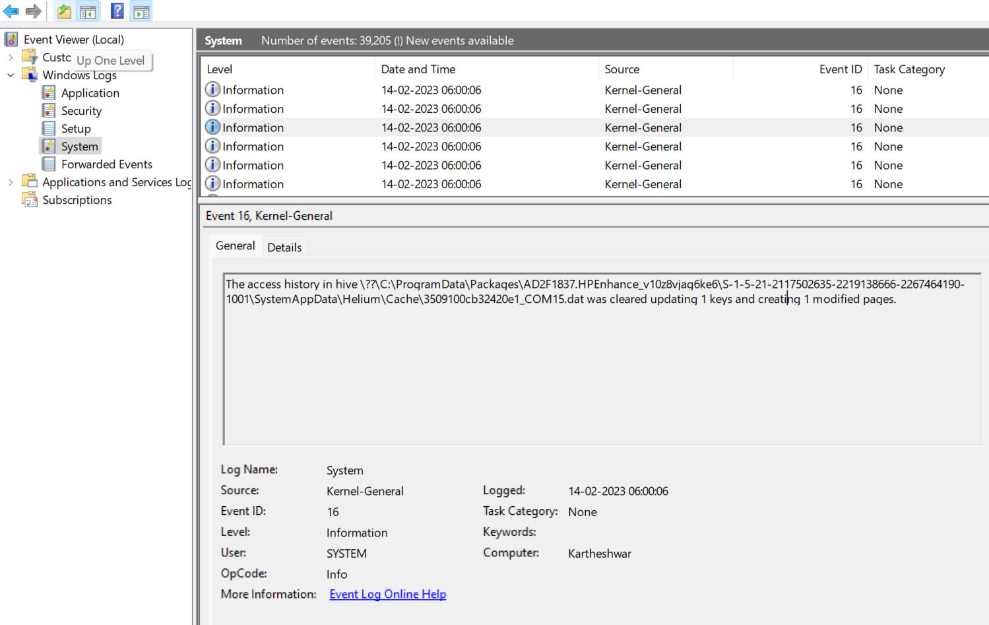

**CONCLUSION:**

**DATA STREAMING**

**How data streaming works**

Companies can have thousands of data sources that get piped to different destinations. The data can be processed using [stream processing techniques](https://www.bmc.com/blogs/event-stream-processing/), and generally consists of small chunks of data.

Streaming data allows pieces of data to be processed in real or near real-time. The two most common use cases for data streaming:

* Streaming media, especially video
* Real-time analytics

Data streaming used to be reserved for very select businesses, like media streaming and stock exchange financial values. Today, it’s being adopted in every company. Data streams allow an organization to process data in real-time, giving companies the ability to monitor all aspects of its business.

The real-time nature of the monitoring allows management to react and respond to crisis events much quicker than any other [data processing methods](https://www.bmc.com/blogs/batch-processing-stream-processing-real-time/). Data streams offer a continuous communication channel between all the moving parts of a company and the people who can make decisions.

**Streaming media:**

This allows users to begin viewing the data (video) sooner, and, in the case of media streaming, prevents the user’s device from having to store large files all at once. Data can come and go from the device as it is processed and watched.

**Challenges with data streaming**

Data streams offer continuous streams of data that can be queried for information.

Generally, the data will need to be in order, which is sometimes the point of having a stream. (After all, any messaging app needs to have all the messages in order.)

Because data may come from different sources, or even the same source, but it moves through a distributed system, it means the stream faces the challenge of ordering its data and delivering to its consumer. So data streams directly encounter the [CAP theorem](https://www.bmc.com/blogs/cap-theorem/) problem in its build. When choosing a database or a particular streaming option, the data architect needs to determine the value between:

* **Having consistent data**, where all the reads received are the most recent write, and, if not return an error.
* **Having highly available data**, where all the reads contain the data, but they might not be the most recent.

CONCLUSION:

**THANKING YOU**

G KARTHESHWAR

12014169